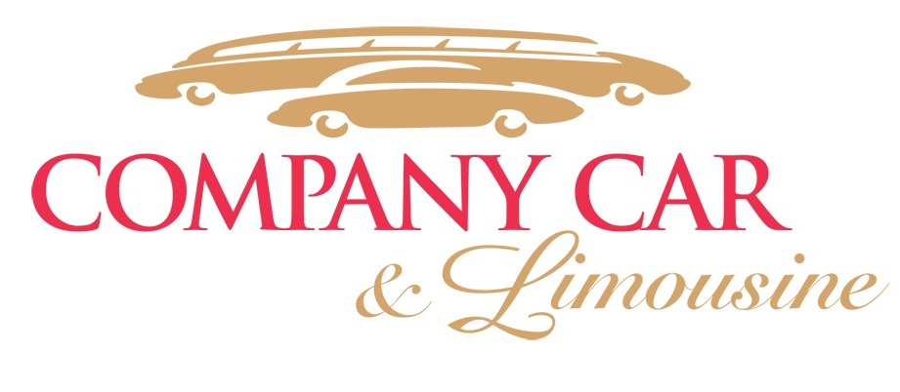

2425 Saint Clair Ave

Cleveland, OH 44114

Ph: (216)861-7433

Email: [reservations@companycarlimo.com](mailto:reservations@companycarlimo.com)

[www.companycarlimo.com](http://www.companycarlimo.com)

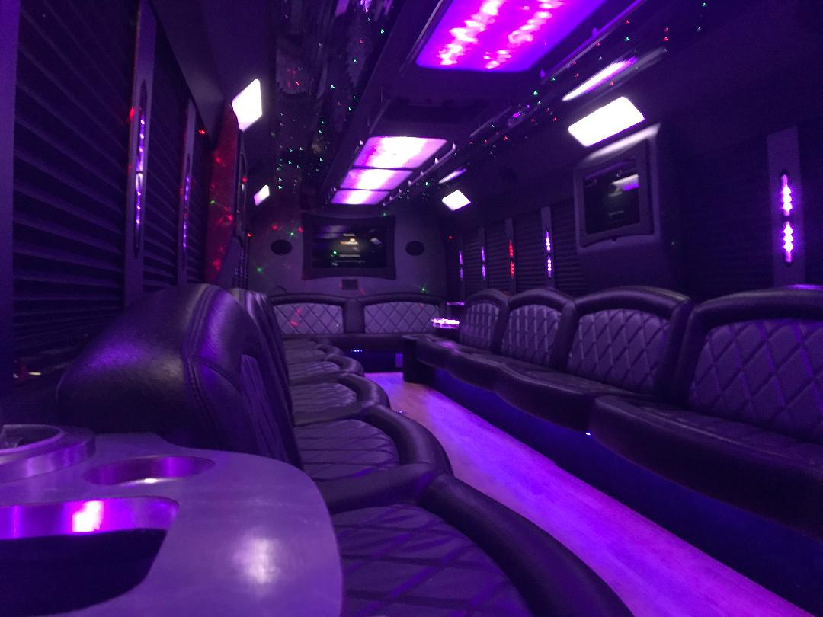

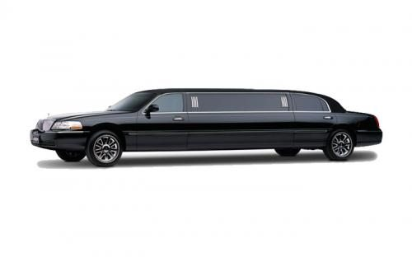

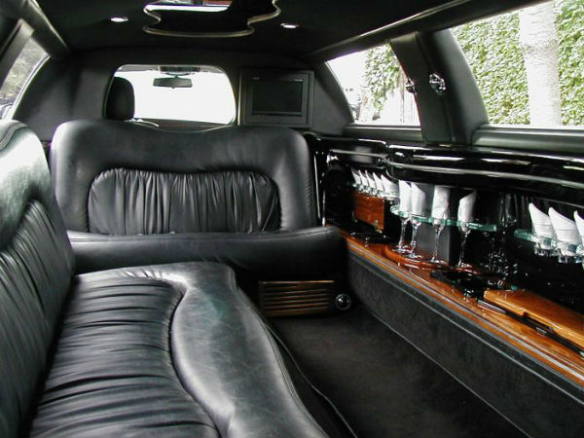

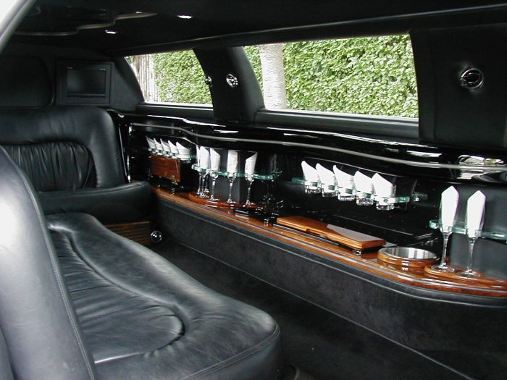

**Stretch Limousine 10**

For proms, weddings, graduations or just special nights on the town, we can customize a package that will exceed the needs of even the most discerning customer. These limousines boast impressive amenities to create a luxurious experience for every passenger.

**Our Stretch Limousines feature:**

~ Classic Limousine Design ~ State of the art surround sound systems

~ Luxurious Plush Leather seating ~ LCD Televisions

~ Premium Touch Screen Bose Audio System ~ Ceiling & Bar Fiber Optic Lighting

~ Climate Control ~ Beverage Bar with large insolated coolers

~ Multiple Charging Stations ~ CD & iPod/MP3 Connection

A Touch of Class Limousine Service is the premier ground transportation provider of Northeast Ohio. With over 34 years in operation and a reputation of providing the best in vehicles, exceptionally trained chauffeurs, and outstanding customer service. When reserving your transportation services with A Touch of Class you are guaranteed to receive a new clean vehicle with all the safety, security, and luxury you come expect when booking a professional ground transportation provider.

**To Reserve Call (330) 225-5382 or Email INQ@atoclimo.com**

**Ask for the Hybrid VIP Coach When Inquiring**